LINUX: Exercises about files manipulation

Part 1

Create a file called “awards” in your home directory, containing
JESSE#EISENBERG#THE SOCIAL NETWORK#ACTOR
COLIN#FIRTH#THE KING’S SPEECH#ACTOR
HALLE#BERRY#FRANKIE AND ALICE#ACTRESS
NATALIE#PORTMAN#BLACK SWAN#ACTRESS
DARREN#FINCHER#THE SOCIAL NETWORK#DIRECTOR
ANNETTE#BENING#THE KIDS ARE ALRIGHT#ACTRESS

- Add a new line, containing CHRISTOPHER#NOLAN#INCEPTION#DIRECTOR, at the end of the file. You should complete this exercise using commands instead of file editors.
cat >> awards (then we add the line)

Another option: echo “CHRISTOPHER#NOLAN#INCEPTION#DIRECTOR” >> awards

- Create a file called “actors” in which you only include ACTORS
grep "#ACTOR$" awards > actors

More complex options:
grep -E "^[^#]*#[^#]*#[^#]*#ACTOR" awards > actors
grep -E "^([^#]*#){3}ACTOR" awards > actors
awk -F "#" '{ if ($4 == "ACTOR") {print}}' awards > actor

- Display the files which begin with a in your home directory

Two options:
ls -d $HOME/a*
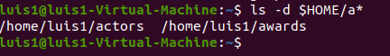

ls $HOME | grep “^a”

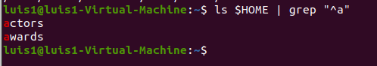

- Create a file called “directors” in which you only include DIRECTORS
grep "#DIRECTOR$" awards > directors

More complex options:
or grep -E "^[^#]*#[^#]*#[^#]*#DIRECTOR" awards > directors
or grep -E "^([^#]*#){3}DIRECTOR" awards > directors
or awk -F "#" '{ if ($4 == "DIRECTOR") {print}}' awards > directors

- Display the lines of “awards” containing actresses. Show the line number.

grep -n "#ACTRESS$" awards

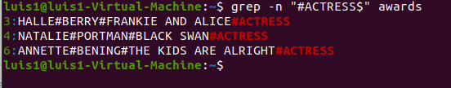

More complex options:
grep -nE "^[^#]*#[^#]*#[^#]*#ACTRESS" awards
grep -nE "^([^#]*#){3}ACTRESS" awards
- Display the lines in “awards” which are not directors. Show the line number.
grep -nv “#DIRECTOR$” awards

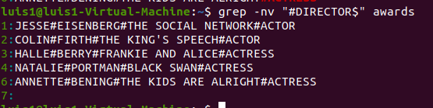

More complex options:
grep -nEv "^[^#]*#[^#]*#[^#]*#DIRECTOR" awards
awk -nF "#" '{ if ($4 != "DIRECTOR") {print}}' awards

Part 2

Create the file called “people.txt”
Ana;Perrrrrrrales;1000
Pedro;Soria;1600
Jacinto;Manzano;500
Claudia;Pastor;600
Xavier;Granados;1000
Soraya;Annnnnnnneja;3000
Xavier;Guerra;4500
Sara;Siria;675
Pablo;Serrano;1000
Sonia;Mono;1600

- Create a file called “people2.txt”, containing those people whose name begins with J or S.
grep "^J" people.txt > people2.txt

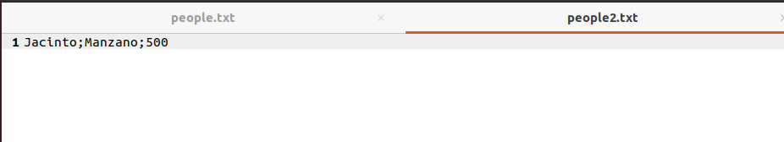

grep "^S" people.txt >> people2.txt
or
grep "^[JS]" people.txt > people2.txt

- Create a file called “people3.txt”, containing those people whose names do not begin with S
grep -v "^S" people.txt > people3.txt

or
grep "^[^S]" people.txt > people3.txt

- Display people whose name begin with S and redirect to file to “people_s.txt”
grep "^S" people.txt > people_s.txt

- Display the number of people whose name begins with A (case insensitive).
grep -ic "^A" people.txt

- Display how many people earn 1000 and concatenate the result in people2.txt
grep -c "1000$" people.txt >> people2.txt

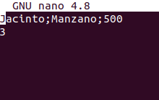

Part 3

- Create a file called list, including the contents from the current directory
ls -R > list

- Open the file to check if the content is right using cat, more and less and observe the differences
cat list
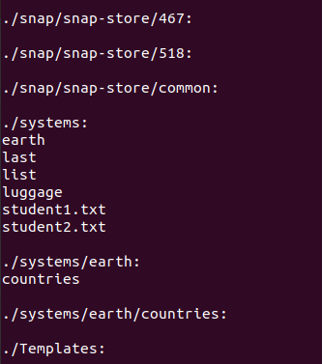

more list
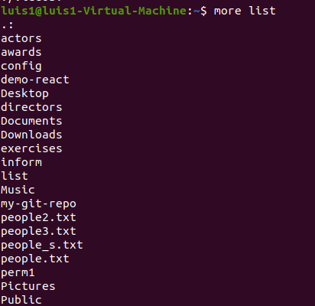

less list

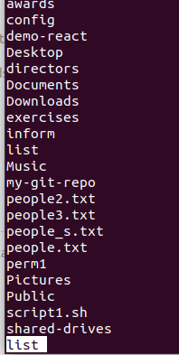

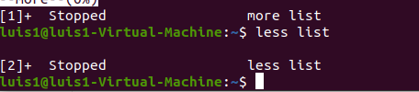

- Print the contents of the current directory in reverse alphabetical order.

ls -r
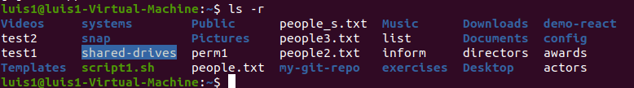
or
ls | sort -r

- Create a file called inform, containing the long format list of the files and directories in your home directory
(ls -l $HOME) > inform

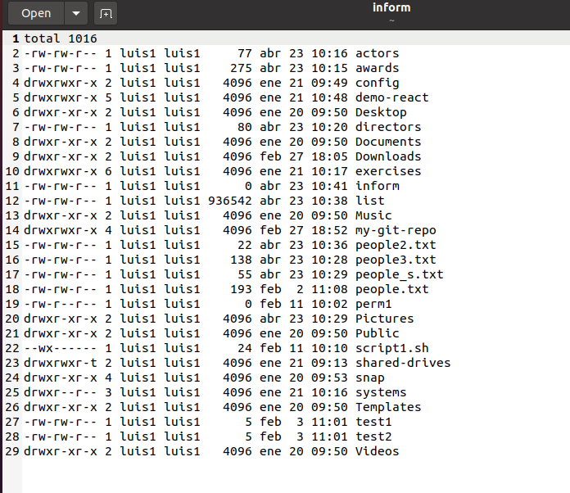

- Find the word FILE in each file of your home directory, ignoring case and showing the line number (create files containing this word if you want any match).

echo FILE > $HOME/test1; echo FILE > $HOME/test2 (a way to quickly create test files containing FILE)

grep -iwn "FILE" $HOME/* 2> /dev/null

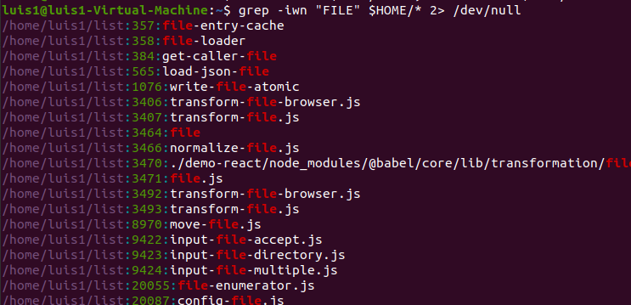

(the -w option forces the exact “file” word, for example profile would not be valid)

